ข้อ 1  
[Sepolia Transaction Hash (Txhash) Details | Etherscan](https://sepolia.etherscan.io/tx/0xcea8ce1a3d2c2d9e027cc7885e2d83bd1ed0965decc4e768d20856b3c609176f)

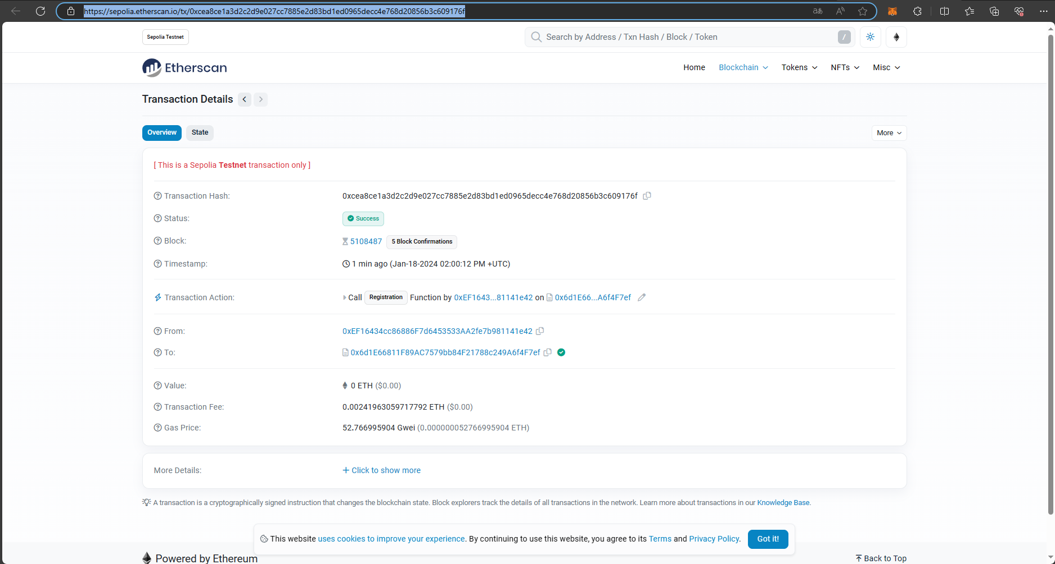

ข้อ 2

0x5614ad9351129f3d87bd7f401011c6adc34a08c7e96ed08cfea76d124b7fe16f

